**Setup Antenna Rotator**

[Hardware Setup](mk:@MSITStore:C:\Ham%20Radio\Logger32\w5ifp\Logger32.chm::/HardwareSetup.htm) ›› [Rotators](mk:@MSITStore:C:\Ham%20Radio\Logger32\w5ifp\Logger32.chm::/Rotators.htm) ›› Alpha Spid

4X1WQ Dr. Avi Rochman and W5IFP Jim Hargrave

1. General

Alpha Spid (Direct support is provided, however some models use the HyGain DCU-1 protocol)

This section covers setup off the ALPHA SPID RAU Rotor with ROT1Prog controller to communicate with Logger32

1. Following is the recommended Rotor setup. Insert the proper Com number and verify the Baud rate.

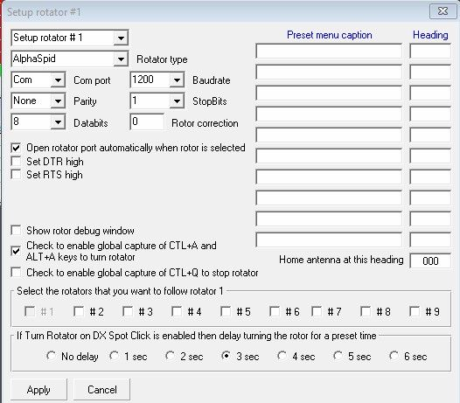

AS_1

3. Setup the controller.

Press the “F” button on the ROT1Prog controller to "A MODE".

Note: In AUTO Mode, the controller will respond to commands from Logger32. The **“<“**and **“>”** buttons can still be used as a manual override.

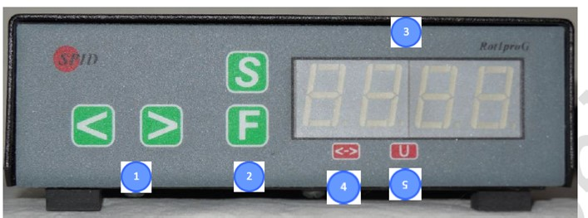

AS_2



AS_3

-

AS_3